News Release

FOR IMMEDIATE RELEASE
FM Area Diversion Project Work
Recognized at P3 Awards

FARGO, ND (October 14, 2022) – Some of the efforts and people behind the FM Area Diversion comprehensive project received accolades this week. The P3 Awards highlights the top accomplishments in public-private partnerships.
The winners tied to the flood mitigation infrastructure project include:
  - Public Sector Promoter/Procurer of the Year – Judges were impressed with the work to date of the Metro Flood Diversion Authority and “welcomed its ability to bring so many different jurisdictions and stakeholders together. They considered it to be an exemplar in the way to manage a major new program of investment,” according to the awards booklet.
  - Best Financial Structure – This project “threads the needle on debt sources, credit risk, structure and timing complication,” judges said of the FM Area Diversion comprehensive project and the work of Agentis Capital. They “commended the pathfinding nature of the deal and its successful use of green financing.”
  - Legal Advisor of the Year – In receiving this recognition, Ashurst was heralded for advising the MFDA “on its pioneering flood diversion P3,” including providing “strategic advice over the development of the project.” John Shockley, the MFDA’s bond and legal counsel, was short-listed for this award.
Others involved with the diversion project also had been shortlisted for awards, including Joel Paulsen, MFDA executive director, for Future Leader of the Year. The work of Shikun & Binui USA, Ashurst and Winston & Strawn also led to the groups being shortlisted together for Best Utilities Project for their work on the diversion.
“Our focus, first and foremost, is delivering permanent flood protection to the Fargo-Moorhead metro community,” Paulsen said. “Recognition like this helps to affirm that we are not only on the right path, but that we are excelling in how we have come together to develop our teams, funding and partnerships.”
These recent awards add to a growing list of recognition the project has received this year. Project Finance International named it the Americas P3 Deal of the Year, IJ Global named it North America’s Water Deal of the Year and Public Sector Project of the Year, and Proximo Infra named it the North America Water Deal of the Year. Additionally, Environmental Finance named it the Green Social and Sustainability Loan of the Year and International Finance Law Review gave it the Americas Award for Public Finance.
The FM Area Diversion uses a split-delivery approach for construction, with a portion being delivered through a public-private partnership with the Red River Valley Alliance and its design and construction arm, ASN Constructors. As the P3 developer, RRVA is building the 30-mile diversion channel as well as aqueducts, road and railroad crossings, drainage inlets and the diversion outlet.
About the Metro Flood Diversion Authority
The MFDA is a permanent North Dakota political subdivision that is cooperatively implementing the Fargo-Moorhead Area Diversion comprehensive project with the U.S. Army Corps of Engineers. The MFDA works in partnership with the Red River Valley Alliance in a public-private partnership as well as the City of Fargo, City of Moorhead, Cass County, Clay County and the Cass County Joint Water Resource District. More information is available at www.FMDiversion.gov.
###

High-resolution photos and b-roll are available. Photos can be downloaded at www.FMDiversion.gov/news. For b-roll, contact amy@neonloon.com.

Photos
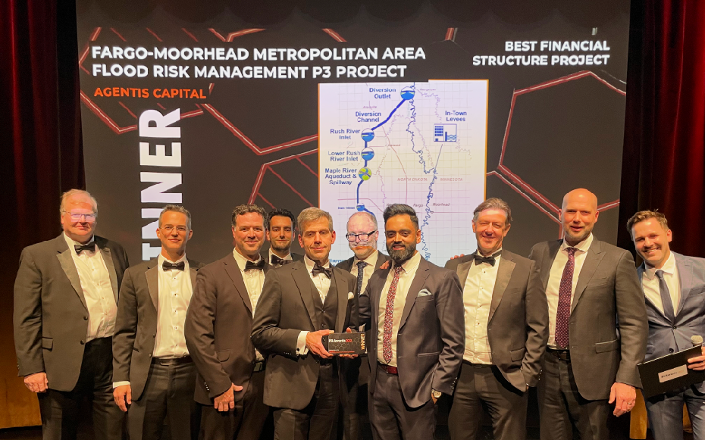
MFDA_P3Awards.jpg: John Shockley (center), bond and legal counsel for the Metro Flood Diversion Authority, holds the award for the Best Financial Structure Project during the P3 Awards. Joining him in accepting the award is Joel Paulsen (third from left), MFDA executive director, and representatives with Agentis Capital, which was instrumental in partnering with the MFDA in developing the financial plan.

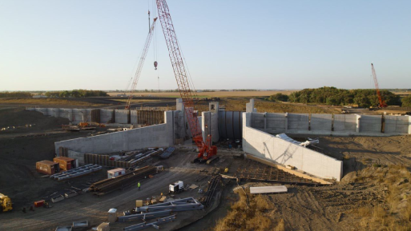
MFDA_WildRiceRiverStructure.jpg: Work on the FM Area Diversion comprehensive project was recognized with a series of P3 Awards on Oct. 11, 2022. The Wild Rice River Structure, pictured here, is a component of the major infrastructure that will protect the Fargo-Moorhead metropolitan area from catastrophic flooding.

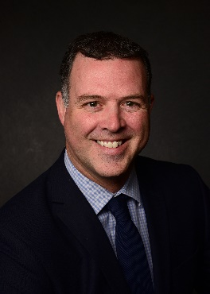
MFDA_JoelPaulsen.jpg: Joel Paulsen, executive director, Metro Flood Diversion Authority

Videos
https://youtu.be/c-SErb0a7zc: Joel Paulsen, Metro Flood Diversion Authority executive director, and Tom Fuchs, MFDA senior construction manager, discuss what it means to be shortlisted for the Public Sector Promoter/Procurer of the Year at the P3 Awards.

https://youtube.com/playlist?list=PLJ7D4q2cAmI9I0AEx_x_iWhVtjJDijUsx: Monthly construction updates show progress being made on the FM Area Diversion comprehensive project.

